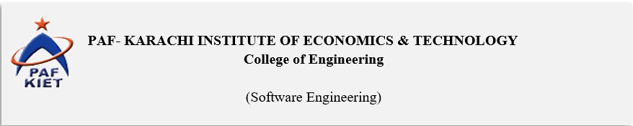



**Software Requirements Specification for**

School Management System

**Prepared by**

**AHSAN NADEEM 10812 (LEADER)**

**M.MUNEEB 10731**

**PAF-KIET**

**27/3/2021**

Faculty Signature: Remarks/Comments:

Table of Content

1. Introduction 1
   1. Purpose 1
   2. Intended Audience and Reading Suggestions 1
   3. Project Scope 1
   4. References 1
2. Overall Description 2
   1. Product Features 2
   2. User Classes and Characteristics 2
   3. Operating Environment 3
   4. Design and Implementation Constraints 3
   5. User Documentation 4
3. System Features 4
   1. LOGIN 4
   2. Student Management 4
   3. Internal Messaging 5
   4. Exam Management 6
   5. Employee Management 7
   6. Class Management 7
4. External Interface Requirements 8
   1. User Interfaces 8
   2. Hardware Interfaces 8
   3. Software Interfaces 9
5. Other Nonfunctional Requirements 9
6. Performance Requirements 9
7. Safety Requirements 10
8. Security Requirements 10
9. Other Requirements 10

**Revision History**

|  |  |  |  |
| --- | --- | --- | --- |
| **Name** | **Date** | **Reason for Changes** | **Version** |
|  |  |  |  |
|  |  |  |  |

# Introduction

## Purpose

###### This SRS Document contains the complete software requirements for the **Online School Management System** (OSMS) and describes the design decisions, architectural design and the detailed design needed to implement the system. It provides the visibility in the design and provides information needed for software support. New reliable and fast **school management software** with the great customer’s support. It'll help you with your daily school management routines and deliver you reliability from your paperwork.

## Intended Audience and Reading Suggestions

###### The primary audience for this SRS document is intended are those people that relates to the schools like admin.

###### The SRS is also intended for the developers, project managers etc.

###### The rest of SRS include all the information or details related to the development and working of the project in abstract form.

## Project Scope

###### Online School Management System is developing for general purpose and used to replace old paper work system and PUMS. OSMS is to build upon the existing information system PUMS in order to efficiently provide student information to teachers and school administration. This increase in efficiency of result making, provide result to parents, give feedback to student, finally, publication and email student result. Our OSMS product usage makes work done at the faster way the software is applicable to view the fee details provided by the administrator of the organization and student can edit his personal details which can be viewed by the administrator.

## References

#### Software Engineering’ by K.K. Aggarwal & Yogesh Singh, New Age Publishing House,

#### 2nd Ed.

#### IEEE Recommended Practice for Software Requirements Specifications – IEEE Std 830-1998.

#### IEEE Standard for Software Test Documentation – IEEE Std. 829-1998.

# Overall Description

## Product Features

Our product main features include

* + - Multi-user account system
    - Reduces the manual workload.
    - Complete details of the Student’s / Employee can be stored and retrieved.
    - Admin can see all the Student’s / Employee details and also export to excel sheets.
    - Student Management
    - Internal Messaging
    - Exam Management
    - Employee Management
    - Class Management

## User Classes and Characteristics

Users of the system should be able to retrieve Student information from the database. The system will support three types of user privileges Admin, Student, and Employee. Student will have access to Student functions, and the Employees will have access to both Student and Employee management functions. The Student should be able to do the following functions:

##### Student:

Frequency of use: MEDIUM

Student will be able to use the following functionalities of the system

* + - Can view the overall progress
    - Modify or Add his/her personal information.
    - Check attendance of respective subjects.
    - View Exams results
    - View Class Schedule

##### Admin:

Frequency of use: HIGH

Admin can use following product functions

* + - Update / Delete any information about students
    - Update / Delete any information about staff.
    - View student overall progress and take action accordingly
    - Create events (exhibition etc.)
    - Add / Update classes.
    - Add / Update Parent

Teacher:

Frequency of use: HIGH

Teacher can use following product functions

* + - Manage the result and performance of Students.
    - Maintain Academic Information about Student.
    - Mark Attendance of student
    - Modify or Add his/her personal information

Parent:

Frequency of use: HIGH

Parent can use following product functions

* + - View Child academic progress (Marks etc.).
    - View Child attendance in respective subjects.
    - Modify or Add his/her personal information
    - Can receive notifications/message about student information (results, attendance).

## Operating Environment

Operating environment for the School management system is as listed below.

* Operating system: Windows
* Database: MySQL database
* Platform: JavaScript/HTML/CSS/Asp.Net/PHP

## Design and Implementation Constraints

This project is developed with Asp.Net using Visual Studio as IDE. It uses a modular design where every feature is wrapped into a separate module and the modules depend on each other through well-written APIs.

There are limitations to what the social media APIs allow developers to do specifically, due to privacy restrictions and anti-data mining concerns, many actions are unavailable. These restrictions limit the ways that users can communicate on each

website.

The application needs to support various methods of input, including both facial expressions and mental commands. Depending on the stage of the disease the user may or may not have the ability to perform each of these actions. This requires different input methods for the user based on their individual impairments.

Language requirements: software must be multilingual, including the following languages: English, Urdu

## User Documentation

With the Project/Product, a user-manual is provided to guide the user how to use this product so that the user can understand the product/project effectively.

# System Features

## LOGIN

###### Description and Priority

This feature provide access to the registered user. Without login into the system, the user will not be able to use the functionalities that the system has to offer

Priority: HIGH

###### Stimulus/Response Sequences

* + - * Login into the system
      * Enter ID and password to authenticate Login

###### Functional Requirements

There are two requirements as.

* + - * ID
      * Password

##### ID:

This contains / stores the IDof user as unique id given to each user i.e., Admin, Teacher, Parent, Student.

PASSWORD:

This stores unique and secured keywords as password that is assign to each user

i.e., Admin, Teacher, Parent, Student.

## Student Management

###### Description and Priority

This feature manages the overall student detail. This feature is accessible to admin, teacher and student

Priority: High

###### Stimulus/Response Sequences

* + - * Login into the system
      * Select Student Management (The features vary according to user that login into the system i.e., admin, teacher, student).

###### Functional Requirements

The requirements as.

* + - * ID
      * Password
      * Add/View/Update

##### ID:

This contains / stores the IDof user as unique id given to each user i.e. Admin, Teacher, Parent, Student.

PASSWORD:

This stores unique and secured keywords as password that is assign to each user

i.e., Admin, Teacher, Parent, Student.

ADD/VIEW/UPDATE:

Admincan add or update student record. It can also utilize the other functionalities of the system.

Parentcan view / monitor student record or overall progress.

Studentcan view his/her record or overall progress or modify his/her personal information.

## Internal Messaging

###### Description and Priority

This feature allows the user to notify or inform to respective person. This feature is accessible to admin, teacher.

Priority: MEDIUM

###### Stimulus/Response Sequences

* + - * Login into the system as teacher or admin
      * Select Message (i.e., admin, teacher)
      * Select Send Message (i.e., admin, teacher).

###### Functional Requirements

The requirements as.

* + - * ID
      * Password
      * Class ID

##### ID:

This contains / stores the IDof user as unique id given to each user i.e. Admin, Teacher.

PASSWORD:

This stores unique and secured keywords as password that is assign to each user

i.e., Admin, Teacher.

CLASS ID:

Class ID stores Id’s of classes that is uniquely identified and assign to each class.

## Exam Management

###### Description and Priority

This feature allows the user to manage all the information that is related to examination. This feature is accessible to admin, teacher.

Priority: MEDIUM

###### Stimulus/Response Sequences

* + - * Login into the system as teacher or admin
      * Select Exam Management (i.e., admin, teacher)

.

###### Functional Requirements

The requirements as.

* + - * ID
      * Password
      * Class ID
      * Subject ID

##### ID:

This contains / stores the IDof user as unique id given to each user i.e., Admin, Teacher.

PASSWORD:

This stores unique and secured keywords as password that is assign to each user i.e., Admin, Teacher.

CLASS ID:

Class ID stores Id’s of classes that is uniquely identified and assign to each class

SUBJECT ID

Subject ID stores Id’s of subjects that is uniquely identified and assign to each subject.

## Employee Management

###### Description and Priority

This feature allows the user to manage all the information of the employee. This feature is accessible to admin, employee.

Priority: MEDIUM

###### Stimulus/Response Sequences

* + - * Login into the system as employee or admin
      * Select Employee Management.

.

###### Functional Requirements

The requirements as.

* + - * ID
      * Password

##### ID:

This contains / stores the IDof user as unique id given to each user i.e. Admin, Employee.

PASSWORD:

This stores unique and secured keywords as password that is assign to each user i.e., Admin, Employee.

## Class Management

###### Description and Priority

This feature allows the user to manage all the information and details of the classes. This feature is accessible to admin, employee.

Priority: MEDIUM

###### Stimulus/Response Sequences

* + - * Login into the system as employee or admin
      * Select Class Management.

.

###### Functional Requirements

The requirements as.

* + - * ID
      * Password
      * Class ID

##### ID:

This contains / stores the IDof user as unique id given to each user i.e., Admin, Employee.

PASSWORD:

This stores unique and secured keywords as password that is assign to each user i.e., Admin, Employee.

CLASS ID:

Class ID stores Id’s of classes that is uniquely identified and assign to each class.

# External Interface Requirements

## User Interfaces

All pages of the system are following a consistent theme and clear structure. JavaScript implement in HTML in order to provide a Data Check before submission. HTML Tables to display information to give a clear structure that easy to understand by user. Error message should be located beside the error input which clearly highlight and tell user how to solve it. The page should display the project process in different color to clearly reflect the various states that student done. Each level of user will have its own interface and privilege to manage and modify the project information such as supervisor able to monitor/manage his student progress and make comment on it, student can change his detail, view the progress, submit project idea.

## Hardware Interfaces

1. Server Side

The web application will be hosted on one of the department’s Linux servers and connecting to one of the school Oracle Database servers. The web server is listening on the web standard port.

1. Client Side

The system is a web-based application; clients are requiring using a modern web browser

such as Mozilla Firebox 1.5, Internet Explorer 6. The computer must have an Internet connection in order to be able to access the system.

## Software Interfaces

|  |  |
| --- | --- |
| **Software used** | **Description** |
| Operating system | We have chosen Windows operating system for its best support and user-friendliness. |
| Database | To save the Student records, Employee records we have chosen MySQL database. |
| Asp.Net | To implement the project, we have chosen Asp.Net language for its more interactive support. |

# Other Nonfunctional Requirements

## Performance Requirements

Easy tracking of records and updating can be done. All the requirements relating to the performance characteristics of the system are specified in the section below. There are two types of requirements.

### Static Requirements:

These requirements do not impose any constraints on the execution characteristics of the system. They are:

* 1. Number of Terminals:

The software makes use of an underlying database that will reside at the server, while the front end will be available online to the administrative and departmental computers as well as students and teachers.

* 1. Number of User:

The number of users may vary, as this software finds applications in almost all departments of the organization.

### Dynamic Requirements

These specify constraints on the execution characteristics of the system. They typically include response time and throughout the system. Since these factors are not applicable to the proposed software, it will suffice if the response time is high and the transactions are carried out precisely and quickly.

## Safety Requirements

If there is extensive damage to wide portion of the database due to catastrophic failure, such as a disk crash, the recovery method restores a past copy of the database that was backed up to archival storage (typically tape) and reconstructs a more current state by reapplying the operations. Backup, recovery & business continuity should ensure adequate back up of data as may be required by their operations. Both data and software should be backed up periodically. An off-site back up is necessary for recovery from major failures / disasters to ensure business continuity.

## Security Requirements

The security requirements deal with the primary security. The software should be handled only by the administrator and authorized users. Only the administrator has the right to assign permission like creating new accounts and generating password. Only authorized users can access the system with a username and password. However, the special requirements of the security market mean that vendors must choose their database partner carefully.

# 6. Other Requirements Appendix A: Glossary

|  |  |
| --- | --- |
| Abbreviation | Full Form |
| OSMS | Online Student Management System |
| PUMS | Project Unit Management System |
| HTML | Hyper Text Mark Up Language |
| CSS | Cascading Style Sheet |
| SRS | Software Specification Requirement |
| PHP | Hypertext Pre-processor |
| MySQL | My Structured Query Language |
| OS | Operating System |
| ID | Identification Data |
| Asp .Net | Active Server Pages Network Enabled Technologies |

**Appendix B: Analysis Models**

<Optionally, include any pertinent analysis models, such as data flow diagrams, class diagrams, state-transition diagrams, or entity-relationship diagrams.>

##### Note: In School Management System Admin Have All Rights to Access All Classes.

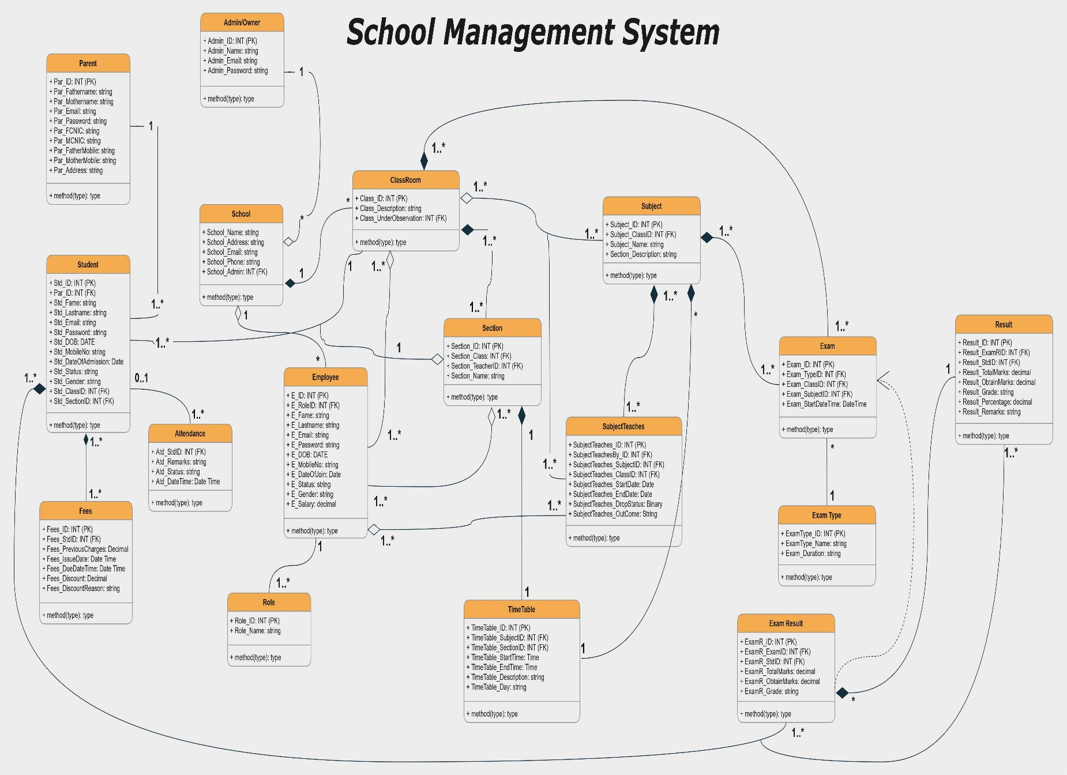

Class Diagram of School Management System.